Test Case: tc001_SPX_Dev5_Crear_Solicitud_Articulo_Almacen
Step 1 - Enter username and password and click to button Enter : Credentials Entered
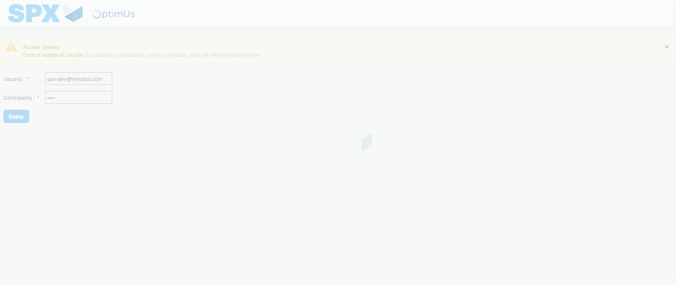Image file-name: QC_Testing-tc001_SPX_Dev5_Crear_Solicitud_Articulo_Almacen-1787939755373

Step 2 - Select to UEN and Access to Request for a New Inventory Item : UEN Correctly selected and Correct access
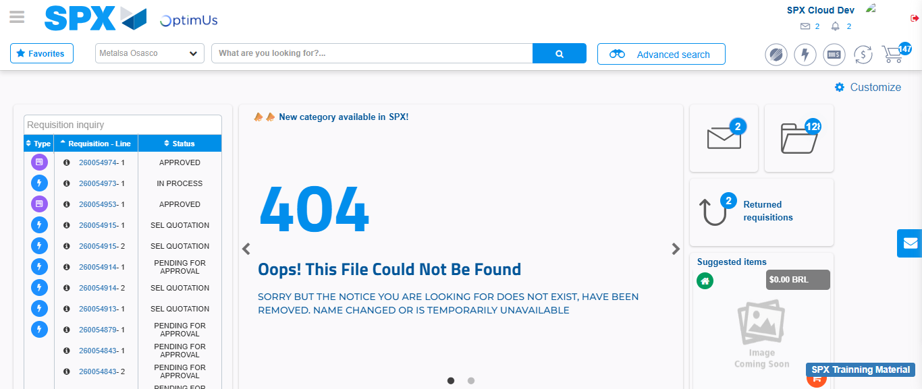Image file-name: QC_Testing-tc001_SPX_Dev5_Crear_Solicitud_Articulo_Almacen-1787939830017

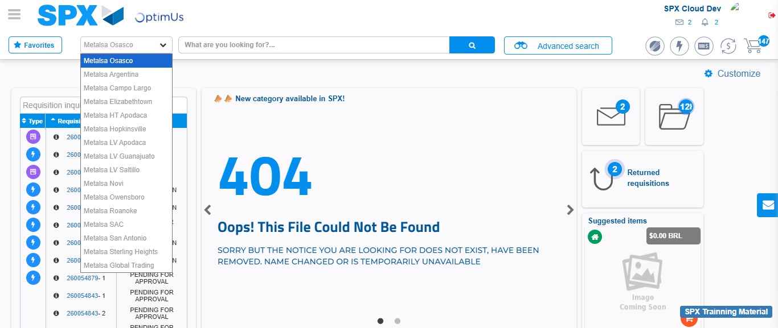Image file-name: QC_Testing-tc001_SPX_Dev5_Crear_Solicitud_Articulo_Almacen-1787939830616

Image file-name: QC_Testing-tc001_SPX_Dev5_Crear_Solicitud_Articulo_Almacen-1787939869741

Step 3 - Select options first section : Options seleted correctly
Image file-name: QC_Testing-tc001_SPX_Dev5_Crear_Solicitud_Articulo_Almacen-1787939870037

Image file-name: QC_Testing-tc001_SPX_Dev5_Crear_Solicitud_Articulo_Almacen-1787939870243

Step 4 - Select options at Screen: Options seleted correctly
Image file-name: QC_Testing-tc001_SPX_Dev5_Crear_Solicitud_Articulo_Almacen-1787939870037

Image file-name: QC_Testing-tc001_SPX_Dev5_Crear_Solicitud_Articulo_Almacen-1787939870243

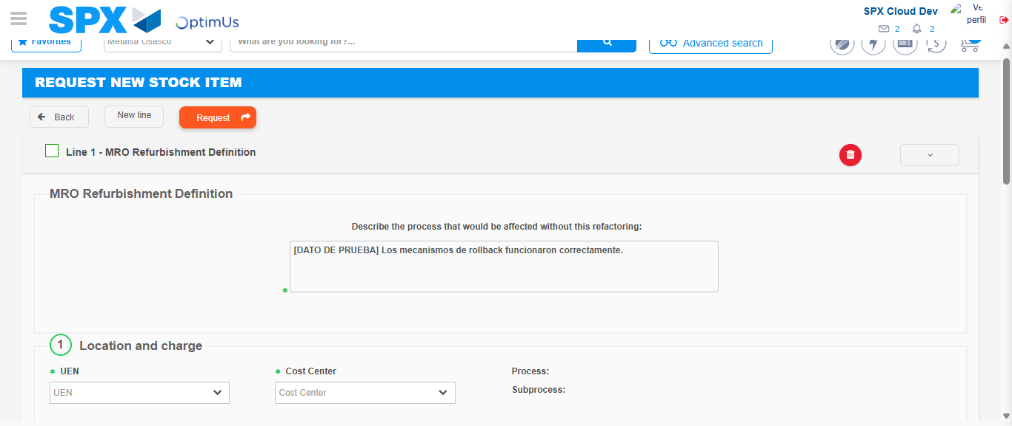Image file-name: QC_Testing-tc001_SPX_Dev5_Crear_Solicitud_Articulo_Almacen-1787939881652

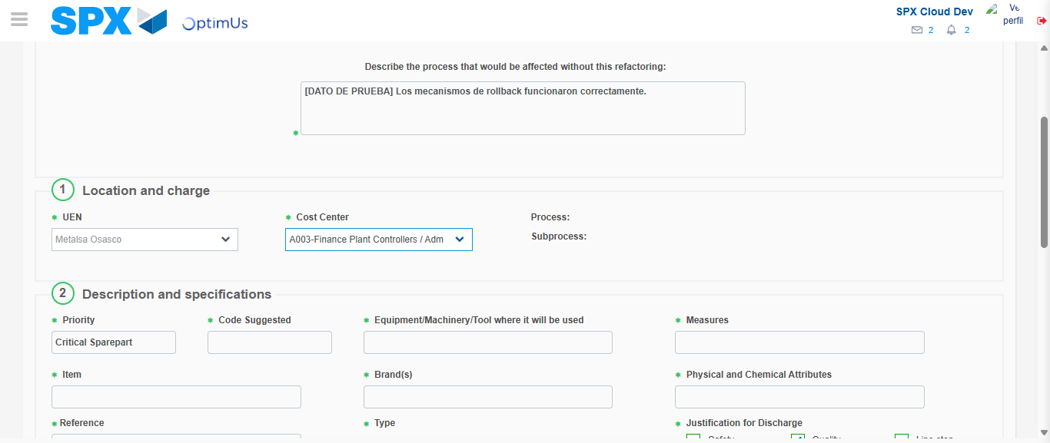Image file-name: QC_Testing-tc001_SPX_Dev5_Crear_Solicitud_Articulo_Almacen-1787939884079

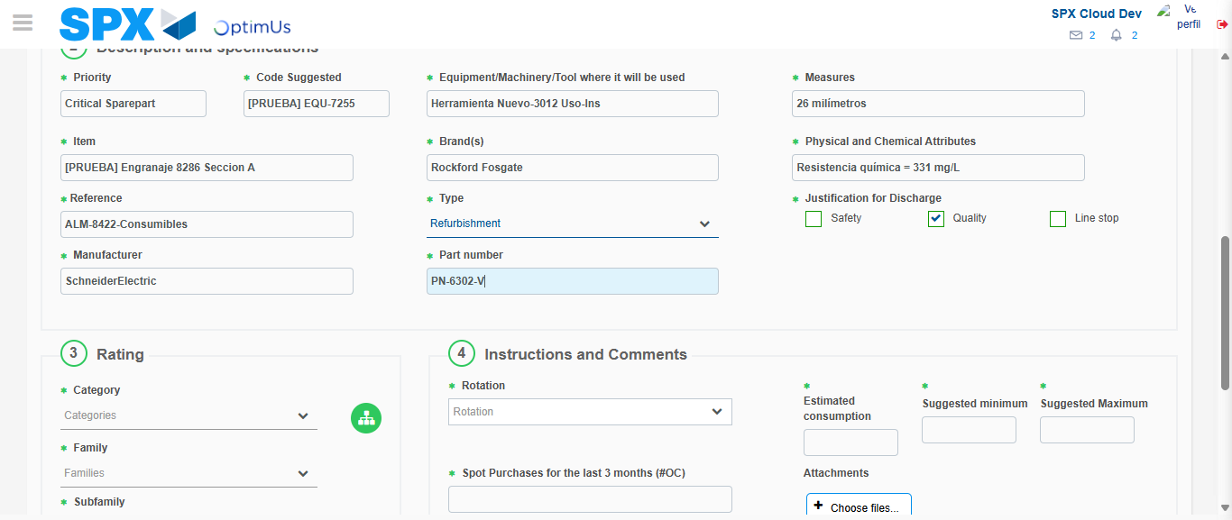Image file-name: QC_Testing-tc001_SPX_Dev5_Crear_Solicitud_Articulo_Almacen-1787939885311

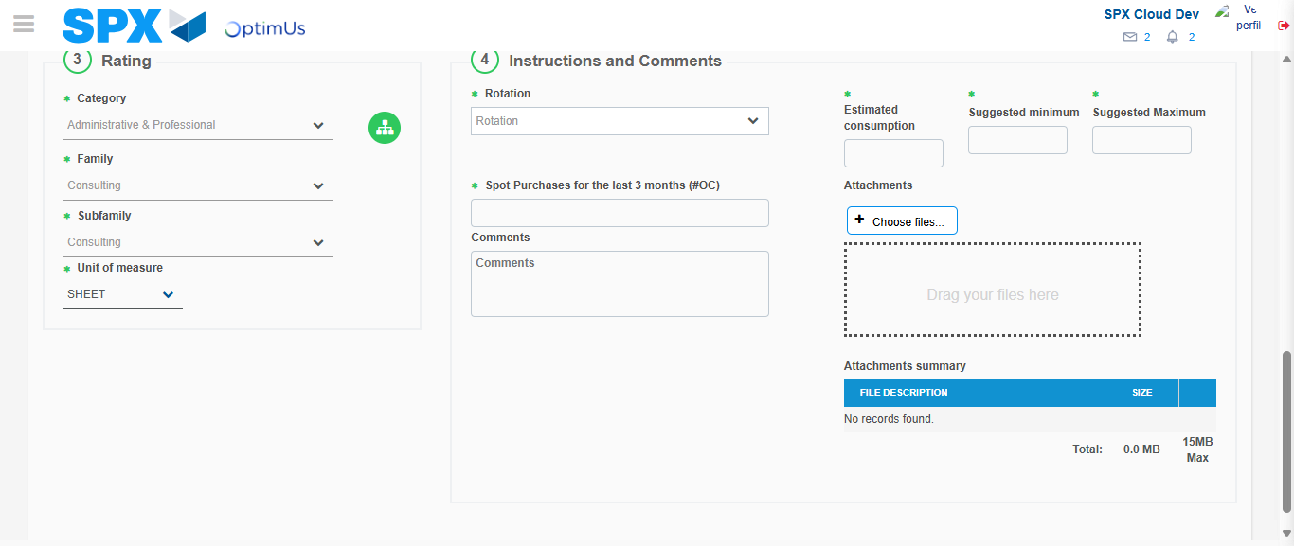Image file-name: QC_Testing-tc001_SPX_Dev5_Crear_Solicitud_Articulo_Almacen-1787939889024

Step 5 - Request New Item : Request Accepted
Image file-name: QC_Testing-tc001_SPX_Dev5_Crear_Solicitud_Articulo_Almacen-1787939830017

Image file-name: QC_Testing-tc001_SPX_Dev5_Crear_Solicitud_Articulo_Almacen-1787939830616

Image file-name: QC_Testing-tc001_SPX_Dev5_Crear_Solicitud_Articulo_Almacen-1787939869741

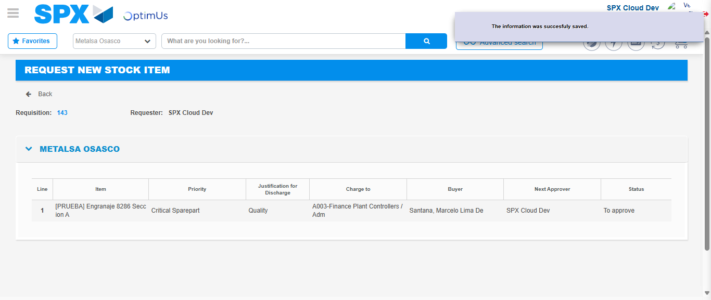Image file-name: QC_Testing-tc001_SPX_Dev5_Crear_Solicitud_Articulo_Almacen-1787939896019

Image file-name: QC_Testing-tc001_SPX_Dev5_Crear_Solicitud_Articulo_Almacen-1787939896193

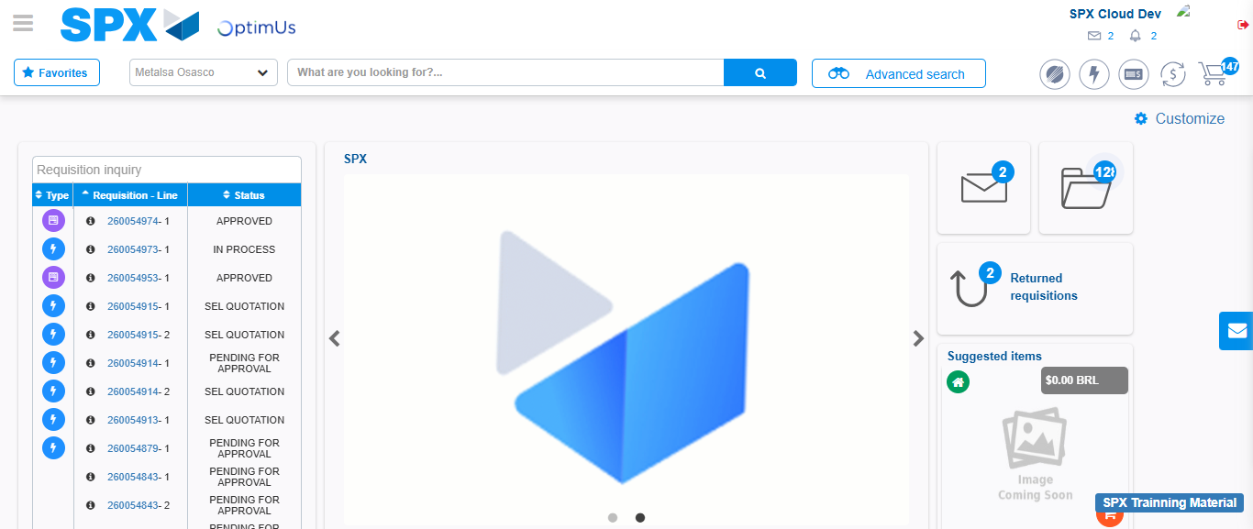Image file-name: QC_Testing-tc001_SPX_Dev5_Crear_Solicitud_Articulo_Almacen-1787939917248

Step 7 - Return to Main Page SPX : Return to Main Page SPX
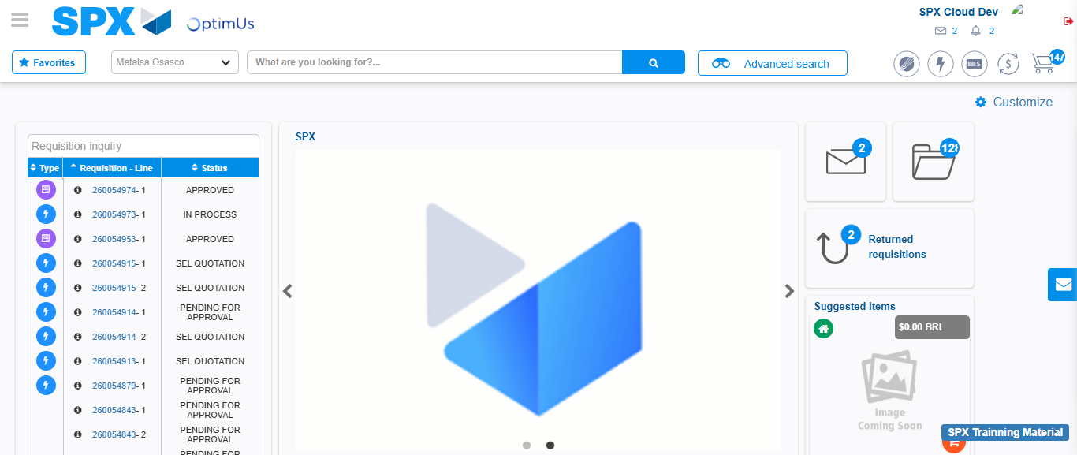Image file-name: QC_Testing-tc001_SPX_Dev5_Crear_Solicitud_Articulo_Almacen-1787939917514

